
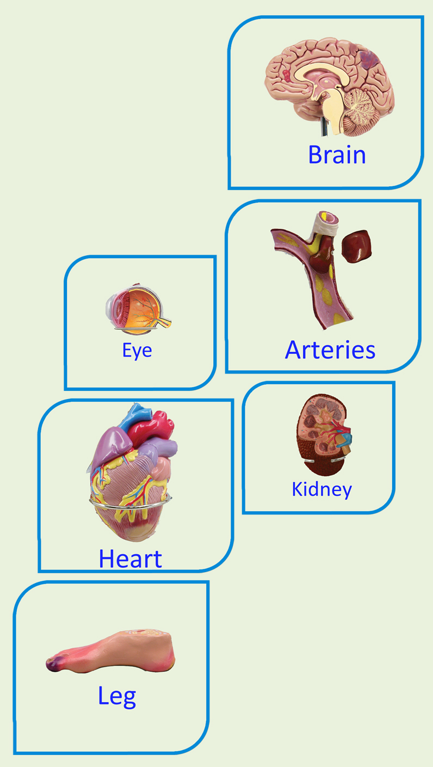
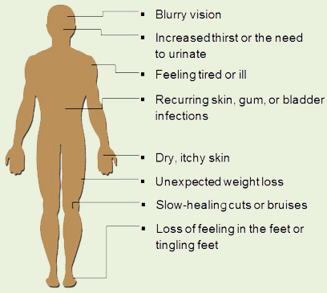
WHO ARE AT RISK?
- Family history of diabetes
- History of gestational diabetes
- Obesity (Men with a waist circumference of 94cm and women 88cm or more are at a substantially increased risk of diabetes.)
- Race/Ethnicity.( European, African, Eastern Mediterranean , Middle Eastern, South Asian, Chinese, Asian-Indian, South & Central American, Japanese)
- Aboriginal and Torres Strait Islander people
- Has a history of high blood pressure

HOW WILL DIABETES AFFECT ME?
TYPES OF DIABETES

TYPE 1
Accounts for 10% of all cases of diabetes in Australia. Type 1 diabetes is also known as insulin-dependent diabetes. A person with type 1 diabetes needs to take insulin to survive because their body makes little or no insulin on its own.

TYPE 2
Type 2 diabetes accounts for more than 85-90% of people with diabetes in Australia. In type 2 diabetes, the pancreas may make enough insulin, but the body cannot effectively use the insulin it creates. This is known as insulin resistance.

- Don’t smoke.
- Have regular medical check-ups
- Keep a positive mental attitude
- Have regular eye examinations.
- Check your feet daily for any changes.
WHAT CAN HAPPEN IF I DON’T TAKE CONTROL?
If your blood glucose levels remain high for prolonged periods of time it can lead to problems such as kidney damage, heart attack, stroke, blindness and loss of feet and legs.
WHAT IS DIABETES?
Diabetes is a disorder in which the body does
not make enough insulin or does not properly use the insulin it produces. Insulin is a hormone that helps balance the amount of glucose in your blood.
HOW CAN I LOOK AFTER MY DIABETES? STEPS TO GOOD HEALTH

- Ask your GP, GP will prescribe medication according to your health condition such as insulin or oral medication.
- Diabetic educator will instruct you about how to check and monitor blood glucose level.
- Dietician will guide you about healthy diet.
- Test your blood glucose levels regularly and record your results
- Follow a healthy eating plan
- Become more active every day





LIVING WELL
MELLITUS TYPE 2
MELLITUS TYPE 2

WITH DIABETES

WHO WILL HELP ME?
A lifelong condition like diabetes is best managed by you with the support of a diabetes team, which may include your GP, diabetes educator, dietician and podiatrist.
SERVICES AND PROGRAMS
- National Diabetes Services Scheme
- National Divisions Diabetes Program
- Diabetes Centres And Educators

COMMUNITY NETWORK SUPPORT GROUP.
For support group, please contact 03 9667 1721

EMERGENCY SERVICE
For Diabetes Emergency Service, please ring +613 8382 2622.

FOR MORE INFORMATION
www.diabetesaustralia.com.au

Congue nihil imperdiet doming id quod mazim placerat facer minim veni am ut wisi enim ad minimeniam, quis erat nostr uexe
rci tation ullamcorper nostru exerci tation ullam corper et iusto odio dig nissim qui blandit praesent lupta. Tummer delenit
augue duis dolore te feugait nulla facilisi. Con erattis sectetuer adip iscing elit, sed erat diam nonummy nibh magna erat.
TIPS FOR FAMILY

Family and friends are an important part of everyday life but when someone has diabetes that encouragement and support can become vital. The following points are designed to help you and others.
- Learn about diabetes and its treatment
- Take time to discuss feelings
- Avoid unrealistic expectations
- Provide effective support

A GUIDE TO HEALTHY EATING FOR PEOPLE WITH DIABETES

REFERENCE:
www.aihw.gov.au
www.acog.org
www.diabetesvic.org.au
www.ndss.com.au

Made By Sanober Ali

