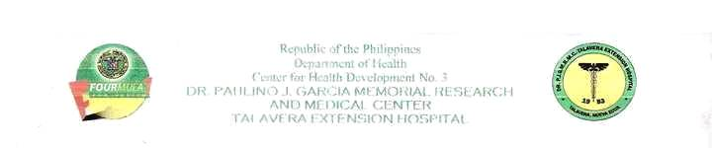
Republic of the Philippines
Department of Health
Center for Health Development No. 3
DR. PAULINO J. GARCIA MEMORIAL RESEARCH
AND MEDICAL CENTER
TALAVERA EXTENSION HOSPITAL

C E R T I F I C A T I O N

This is to certify that Mr. Francis Solomon Sagcal has been a full time volunteer nurse at Dr. Paulino J. Garcia Memorial Research & Medical Center, Talavera Extension Hospital, Talavera Nueva Ecija from 01 November 2010 to 31 May 2011 and from 1st of June 2011 up to present he has been permanently employed as a full time nurse. His duties and responsibilities are as follows.

- Observes, takes records, and reports symptoms and condition of patients.
- Administration of medications as well as noted drug reactions.
- Set up treatment trace, prepares sterile instruments and other equipments needed for a certain special procedure.
- Assist the physician in procedures such as minor surgical cases, delivery as well as in physical examination.
- Maintain records reflecting patients’ conditions, medications and treatments.
- Assist in orientation, incidental teaching and evaluation of personnel and students.
- Assist in patient education and rehabilitation, including promotion of mental and physical health.
- Makes rounds with the doctors.
- Keep the ward clean and orderly.
- Assist head nurse in supervising the attendants and helpers.
- Reports and contacts the head nurse about the needs for supplies, equipments and report of plumbing and appliances.
- Perform post mortem care.
- Makes endorsements of patients’ articles, equipment and the unit.

This is to further certify that Mr. Francis Solomon Sagcal has rendered satisfactory performance in his field of endeavor and no pending administrative or criminal case charged against him. Furthermore, he is well known for his professional and ethical conduct.

This certification is being issued on this 1st September 2011 upon request of the above person for reference purposes.

Mrs. Erlinda U. Fernando
Nurse Supervisor
(63) 9228635314

Dr. Vicente Z. Cruz Jr. MD, MHA
Officer In-charge
(63) 9065148684

